Daniel Landry

CIS-5(40107)

1/30/2017

Project 1

<High or Low Gambling>

Introduction:

Title: High or Low Gambling

High or Low is a card game where the player must play the odds in order to double their earnings or lose it all. The game starts with a two dollar bet that is added to the pot from the player’s earnings. From there, the player has to guess if their card will be higher or lower than the one the dealer has shown. If they guess higher or lower and are correct, they can either add that money to their earnings, add it to the next pot, or check out.

If the player chooses to double the pot, the price of the bet also doubles. This is when the player has the highest chance to earn the most money and simultaneously lose the game. If the pot ever becomes bigger than the available funds of the player and they guess wrong, they automatically lose the game. However, if they guess right they are free to check out (output their winnings in a .dat file) or add it to their existing funds and continue playing with a reset pot of two dollars. If the dealer card is the same value as the player card then the next pot is quadrupled instead of doubled.

This is a game of high risk high reward and to see how much money you can get without going broke.

Summary:

Project size: 395 lines

14 variables used

This program uses all the concepts specified in the check off sheet made in class and makes use of various loops and nesting methods. The project took about 25 hours spanning over 3 days. Though I had a more elaborate game in mind, it proved to be easier to improve on simpler ones in order to meet the deadline.

Gaddis 8th edition was often used as a reference and cleared up syntax errors that occurred often. I only used concepts gone over in class in an attempt to stick to the criteria.

Description:

The point of this program is program is to demonstrate the concepts covered in class as a game.

Flowchart:

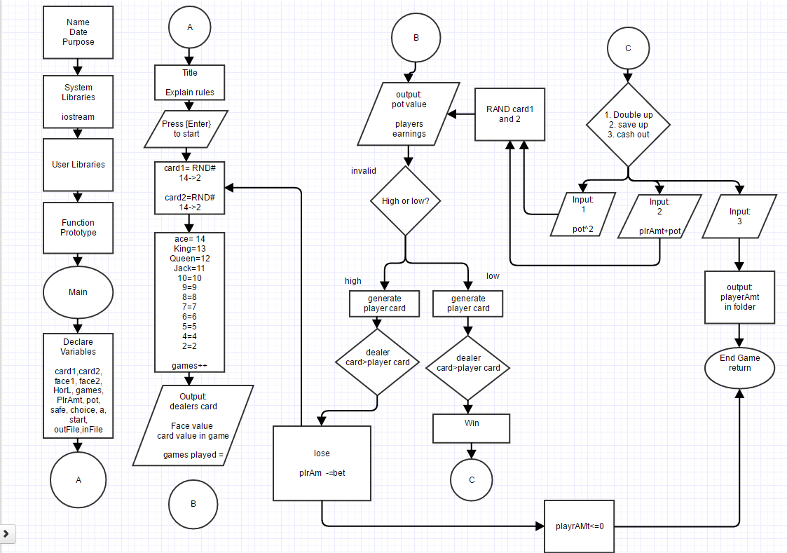

Pseudo Code:

1. program start

2. randomly generate card 1

randomly generate card 2

3. keep count of games

4. decide high or low

5. generate second random number

6. win if guess high, card high

7. double, save or cash out

8. win if guess low, card=low

9. double, save or cash out

10. lose if guess low, card high

Subtract player amount

11. lose if guess high, card low

Subtract player amount

11. if not 'h’ or ‘l' inputs Retry

12. game over if player amount <=0

Major Variables:

1. floats

cardVal= gives the card its face and value (lines 80-132 within switch and if else statments)

crdVal2= gives second card its face and value( lines 163-216 within switch and if else statments)

2. strings

start, = place holder for enter to start the game (line 68)

face1=face of dealer card, (lines 79-131 in switch and if else statements)

face2= face of player card (lines 167-217)

PlrAmt= starting value for player (line 148)

3. unsigned short

card1= the Dealer card corresponding to card/face value (lines 72)

card2= Random card that corresponds with a face/card value (line 73)

choice= switch choice (line 77)

games=1; =place holder for games, initialized 1 (line 139)

4.char

HorL= reads higher or lower (line 155)

5. int

pot=2; =pot value displayed, initialized at 2 dollars( line 149)

a=1; //counter for games (line 140)

6.bool

safe=true; initialized true (line 388)

7. fstream

ofstream outFile;= use to open and add things to this file from program (lines 45 & 254)

ifstream inFile;= used to input predetermined player amount (lines 46 &148)